

# Rossmoyne Senior High School

### Semester One Examination, 2016

### Question/Answer Booklet

# MATHEMATICS

**SOLUTIONS**

**SPECIALIST**

**UNIT 3**

## Section One:

## Calculator-free

|  |  |  |  |  |  |  |  |  |
| --- | --- | --- | --- | --- | --- | --- | --- | --- |
| Student Number: In figures |  |  |  |  |  |  |  |  |

In words

Your name

## Time allowed for this section

Reading time before commencing work: five minutes

Working time for section: fifty minutes

## Materials required/recommended for this section

***To be provided by the supervisor***

This Question/Answer Booklet

Formula Sheet

***To be provided by the candidate***

Standard items: pens (blue/black preferred), pencils (including coloured), sharpener, correction fluid/tape, eraser, ruler, highlighters

Special items: nil

## Important note to candidates

No other items may be taken into the examination room. It is **your** responsibility to ensure that you do not have any unauthorised notes or other items of a non-personal nature in the examination room. If you have any unauthorised material with you, hand it to the supervisor **before** reading any further.

## Structure of this paper

|  |  |  |  |  |  |
| --- | --- | --- | --- | --- | --- |
| Section | Number of questions available | Number of questions to be answered | Working  time (minutes) | Marks available | Percentage of exam |
| Section One:  Calculator-free | 7 | 7 | 50 | 53 | 35 |
| Section Two:  Calculator-assumed | 12 | 12 | 100 | 98 | 65 |
|  | | | **Total** | 151 | 100 |

## Instructions to candidates

1. The rules for the conduct of examinations are detailed in the school handbook. Sitting this examination implies that you agree to abide by these rules.
2. Write your answers in this Question/Answer Booklet.
3. You must be careful to confine your response to the specific question asked and to follow any instructions that are specified to a particular question.
4. Spare pages are included at the end of this booklet. They can be used for planning your responses and/or as additional space if required to continue an answer.

* Planning: If you use the spare pages for planning, indicate this clearly at the top of the page.
* Continuing an answer: If you need to use the space to continue an answer, indicate in the original answer space where the answer is continued, i.e. give the page number. Fill in the number of the question that you are continuing to answer at the top of the page.

1. **Show all your working clearly**. Your working should be in sufficient detail to allow your answers to be checked readily and for marks to be awarded for reasoning. Incorrect answers given without supporting reasoning cannot be allocated any marks. For any question or part question worth more than two marks, valid working or justification is required to receive full marks. If you repeat any question, ensure that you cancel the answer you do not wish to have marked.
2. It is recommended that you **do not use pencil**, except in diagrams.
3. The Formula Sheet is **not** to be handed in with your Question/Answer Booklet.

Section One: Calculator-free 35% (53 Marks)

This section has**seven (****7)** questions. Answer **all** questions. Write your answers in the spaces provided.

Working time for this section is 50 minutes.

Question 1 (6 marks)

Consider , . Solve  over .

|  |
| --- |
| **Solution** |
|  |
| **Specific behaviours** |
| ✓ uses factor theorem to find z-1  ✓ uses division or inspection to determine b  ✓ uses division or inspection to determine a  ✓ uses quadratic equation  ✓ solves  to give two complex roots  ✓ clearly acknowledges all three solutions |

Question 2 (7 marks)

A sphere has equation .

(a) Determine the coordinates of the centre and the radius of the sphere. (4 marks)

|  |
| --- |
| **Solution** |
|  |
| **Specific behaviours** |
| ✓ divides both sides by 2  ✓ completes the squares  ✓ states the radius  ✓ states centre |

(b) Determine the vector equation of the straight line that passes through the points on the sphere where  and . (3 marks)

|  |
| --- |
| **Solution** |
|  |
| **Specific behaviours** |
| ✓ determines x-coordinates of points on sphere  ✓ states direction of line  ✓ states vector equation of line |

Question 3 (8 marks)

(a) Let .

(i) Express z in Cartesian form. (2 marks)

|  |
| --- |
| **Solution** |
|  |
| **Specific behaviours** |
| ✓ real part  ✓ imaginary part |

(ii) Determine  in Cartesian form. (3 marks)

|  |
| --- |
| **Solution** |
|  |
| **Specific behaviours** |
| ✓ uses polar form to determine modulus  ✓ uses polar form to determine argument  ✓ converts to Cartesian form |

(b) If , sketch the location of all roots of this equation on the axes below.

(3 marks)

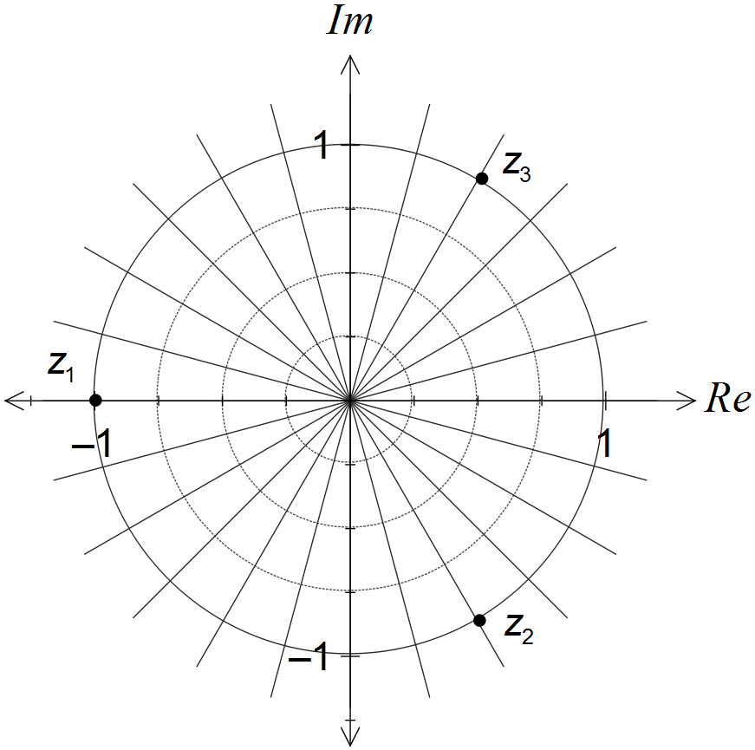

|  |
| --- |
| **Solution** |
| See diagram - evenly spaced points on circle |
| **Specific behaviours** |
| ✓ Adds scale to show real root at -1  ✓ Shows second root third way around circle  ✓ Shows third root as conjugate of second |

Question 4 (7 marks)

Consider the following system of equations, where k is a real constant.



(a) Solve the system of equations when . (3 marks)

|  |
| --- |
| **Solution** |
|  |
| **Specific behaviours** |
| ✓ eliminates x and z to find y  ✓ eliminates and solves for another variable  ✓ states values of all three variables |

(b) Show that no value of k exists for the system of equations to represent three planes intersecting in a single straight line. (4 marks)

|  |
| --- |
| **Solution** |
|  |
| **Specific behaviours** |
| ✓ reduces second and third rows in initial matrix  ✓ reduces third row in second matrix  ✓ indicates condition for planes to intersect in single straight line  ✓ shows that no value of k exists |

Question 5 (8 marks)

(a) Determine the vector equation of the plane that contains the points A(1, -1, 2), B(2, 1, 0) and C(3, -1, 1). (4 marks)

|  |
| --- |
| **Solution** |
|  |
| **Specific behaviours** |
| ✓ finds two vectors in plane  ✓ calculates cross product of two vectors  ✓ substitutes into vector equation of plane  ✓ simplifies vector equation |

(b) Plane  has equation . Line L is perpendicular to and passes through the point (1, -6, 4). Determine where line L intersects plane . (4 marks)

|  |
| --- |
| **Solution** |
|  |
| **Specific behaviours** |
| ✓ writes vector equation of plane  ✓ writes vector equation of line through point  ✓ substitutes line into plane and solves for t  ✓ determines coordinates of point |

Question 6 (7 marks)

(a) Sketch the graph of  on the axes below. (2 marks)

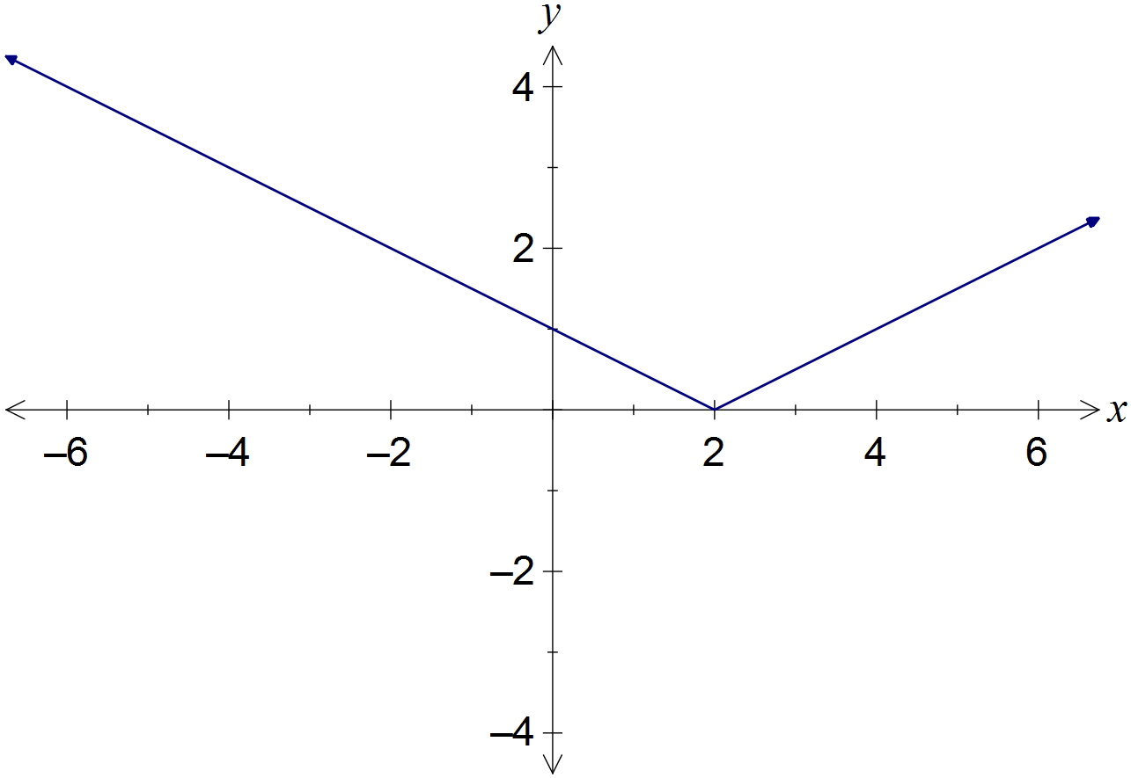

|  |
| --- |
| **Solution** |
| See diagram |
| **Specific behaviours** |
| ✓ v-shape with cusp at (2, 0)  ✓ correct y-intercept |

(b) Solve the equation . (3 marks)

|  |
| --- |
| **Solution** |
|  |
| **Specific behaviours** |
| ✓ separates into cases  ✓ solves first case  ✓ solves second case |

(c) Solve the inequality . (2 marks)

|  |
| --- |
| **Solution** |
|  |
| **Specific behaviours** |
| ✓ determines correct endpoints  ✓ states correct inequalities |

Question 7 (10 marks)

Particle A has position vector given by , where t is the time in seconds.

(a) Show that the path of the particle is circular. (2 marks)

|  |
| --- |
| **Solution** |
|  |
| **Specific behaviours** |
| ✓ converts to Cartesian form  ✓ states centre and radius |

Particle B is stationary, with position vector .

(b) Determine an expression for the distance between particles A and B in terms of t.

(2 marks)

|  |
| --- |
| **Solution** |
|  |
| **Specific behaviours** |
| ✓ determines vector **BA** (or **AB**)  ✓ states magnitude of vector |

(c) Determine the position vector of the A when it is (i) nearest and (ii) furthest from B.

(6 marks)

|  |
| --- |
| **Solution** |
| Let S be square of distance between particles: |
| **Specific behaviours** |
| ✓ differentiates S  ✓ simplifies and equates derivative to 0  ✓ determines solution for tan t  ✓ derives possible values for sin t and cos t  ✓ determines nearest position  ✓ determines furthest position |

Additional working space

Question number: _________

Additional working space

Question number: _________

© 2016 WA Exam Papers. Rossmoyne Senior High School has a non-exclusive licence to copy and communicate this paper for non-commercial, educational use within the school. No other copying, communication or use is permitted without the express written permission of WA Exam Papers.